**Sage 300**

**CashViewTM User’s Guide**

Nov 2019

This is a publication of Sage Software Asia Pte Ltd

(c) 2019 The Sage Group plc or its licensors. All rights reserved. Sage, Sage logos, and Sage product and service names mentioned herein are the trademarks of The Sage Group plc or its licensors. All other trademarks are the property of their respective owners.

Last updated: November 27, 2019

CONTENTS

Chapter 1: Introduction 5

Chapter 2: Setting up the system 7

Setting up CashViewTM 7

Before You Start 7

Using Settings Options 8

Additional Notes on Settings/Options 11

Chapter 3: Security Configuration 12

Create Security Groups 12

Authorizing User 13

Chapter 4: Using the CashViewTM Inquiry Function 14

Functions available 15

Dashboard 16

Cash Flow Summary 19

A/R Summary - Top 10 Outstanding Balance 19

A/P Summary – Top 10 Outstanding Balance 20

Appendix A: Understanding CashViewTM reports 25

Appendix B: Customization 37

Chapter 1: Introduction

CashViewTM takes a fresh approach to cash flow management. Its design allow for it to perform with a “bot” like behaviour. Quietly working behind the scene, this program will retrieve financial data, process them and determine if you are facing a cash flow crunch. And, if so it uses email as the medium to communicate the status to key person/s in the company.

CEO/CFOs who normally do not access Sage 300 can now stay on top of things by having the program informing them as soon as a problem is encountered. By design the program has built in intelligence on cash flow and performs a forward looking analysis so that you are advised of a situation way ahead of time. This allows decision makers to plan ahead and correct problems even before it happens.

Once a situation is identified, then accessing the program will reveal details of the financial health of the business. This is done with the use of a dashboard showing key financial metrics. Further details such as summary and details about your Accounts Payable, Accounts Receivable and Cash-in-hand and in banks, as well as other financial data that you may wish to store can also be reviewed. The latter could be data that are normally kept outside of your accounting system or has yet to be updated into your system.

The program does not end there. In Singapore and Malaysia, Sage in collaboration with Standard Chartered is offering customers the choice to take up pre-validated instalment loans. What this means is that, businesses can apply for such loans via the program as they have been pre-validated. The loan application enjoys special benefits that cover collateral free, low interest rates and fast tracking.

*Note: Throughout the process, there is no financial information sent to Sage or any third-party at any time. Even the email notification to you on such offers will require your consent.*

This program can still fully function (excluding loan) if your business is not indicated to be registered in Singapore or Malaysia. The program will hide the Loan feature automatically.

The following are the modules accessed and used by the program:

* General Ledger
* Accounts Payable
* Accounts Receivable
* Common Services
* Administrative Services

This *User Guide* is specifically for Sage 300. For information on how this program works for Sage 300cloud, please refer to its own document. This document is broken down into chapters so that information on how to setup or use this can be found easily.

**Chapter 1: Setting up the system**

Set up and specify options that determine how the program processes the data as well as determine the frequency data is to be processed and who and how notifications are performed.

**Chapter 2: Security Configuration**

Set up access for users so that only appropriate person in your company can use this function, receive loan notification, submit loan request and print reports.

**Chapter 3: Using the various Functions**

How to use the Dashboard, Cash Summary, A/R Summary, A/P Summary and Loan screens will be covered here.

**Appendix A: Understanding the various reports**

The following are the reports that can be generated from the program. Depending on your access rights, these may or may not be available to a user.

* Dashboard
* Summary Cash Flow Report
* Cash and Bank Accounts
* Inflow and Outflow Entries
* Top 10 Customers Outstanding
* A/R Receivables Forecast
* Top 10 Vendors Outstanding
* A/P Payables Forecast
* Option Settings

**Appendix B: Customization**

Chapter 2: Setting up the system

Use CashViewTM Settings Options screens to set up records and options that determine how CashViewTM will function:

* Processes transactions
* Sends notification

## Setting up CashViewTM

After you activate CashViewTM, follow the steps in this topic to set up the required values that are needed before the program can be used.

## Before You Start

Make sure you have the following modules installed and activated:

* System Manager (including Bank Services and Tax Services)
* General Ledger
* Accounts Payable
* Accounts Receivable
* Optionally, Order Entry and Purchase Orders

Additionally, you must be on these versions of Sage 300 and Sage 300cloud together with their respective product updates/browsers:

* 2016 – 2019 versions with latest product updates.
* Using the following browsers Chrome, Firefox, Edge and Safari. Please note that Internet Explorer support has been deprecated.

Make sure there is at least one month of financial data entered into the system. Generally, the program functions best if it has sufficient data for its computation.

As the program uses email as its medium of notification, you should ensure the following is completed and/or available:

* + Email settings information. See later for information on how to set up your Email configuration.
  + Obtain names and email IDs of persons who should be receiving the loan notification email. As this is a confidential matter, you are advised to seek proper authorisation before you perform this step.

## Using Settings Options

From the menu, select CashViewTM and in the sub-menu choose S/C Setup and run Options.

The settings are separated into 4 sections, namely:

* Company

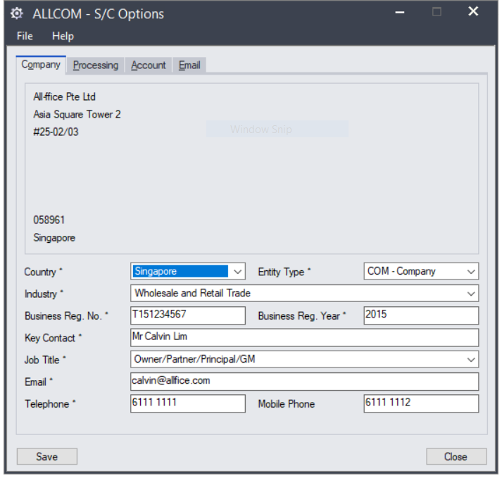

This is where you will define information about your company and contact.

|  |  |
| --- | --- |
| **Fields** | **Purpose** |
| Company Information | The information is taken from Common Services/Company Profile and cannot be edited here. |
| Country | There are only 3 choices, namely Singapore, Malaysia and Others. Choosing Singapore and Malaysia would require additional setups. Choose the appropriate country value that applies. See *Additional Notes* later for more details on the choices. |
| Entity Type | Select the option that best describe your business type. |
| Industry | Select the option that best describe the industry your business is in. |
| Business Reg. No | Enter your local business registration ID. For example, in Singapore this can be your UEN. Entering this may automatically change the Business Reg. Year value. |
| Business Reg. Year | Enter the number of years your company has been in business. This could be automatically filled when you enter a value into Business Reg. No. |
| Key Contact | As the program involves information that may be deemed confidential and sensitive, we suggest that the key contact entered here be either the CEO or the CFO of the company. This contact will be used as the owner of any loan request made (applicable to Singapore and Malaysia registered businesses only). |
| Job Title | Select the most appropriate title for the contact entered. |
| Email | Enter the email of the key contact. |
| Telephone | Enter the office number of the key contact. |
| Mobile Phone | Enter the mobile number (Optional) of the key contact. |

* Processing

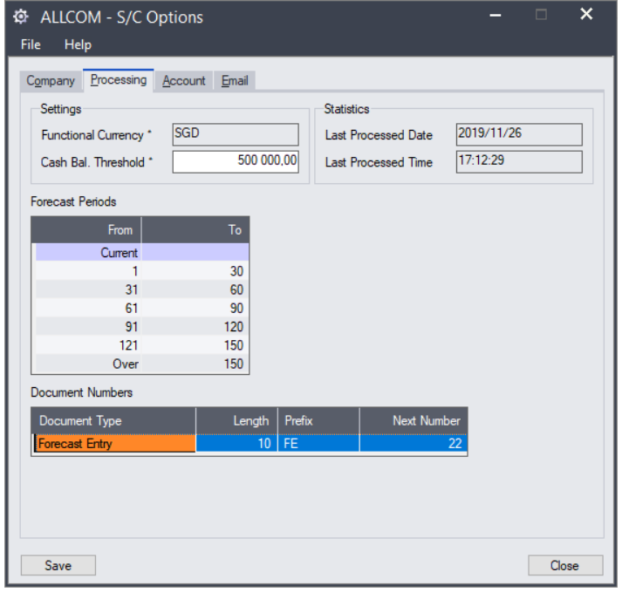

Here you will set the threshold used to monitor your cash flow, how transactions will be grouped and how documents will be numbered.

|  |  |
| --- | --- |
| **Fields** | **Purpose** |
| Functional Currency | This is the Functional (Home) used for the company. It is taken from Common Services in Company Profile and cannot be changed here. |
| Cash Bal. Threshold | This is the threshold amount that you want to compare against for each of the days’ range. You can set the value to cover overheads and burden or you can have these values entered separately as Forecast Entries. |
| Last Processed Date | This is the date when calculation of cash flow was performed by the system. |
| Last Processed Time | This is the time when calculation of cash flow was performed by the system. |
| Forecast Periods | Cash flow forecast are determined by days’ ranges. You can define them here (up to 7 ranges) |
| Document Number | This is where you can determine the document numbering used for Forecast Entries. |

* Accounts

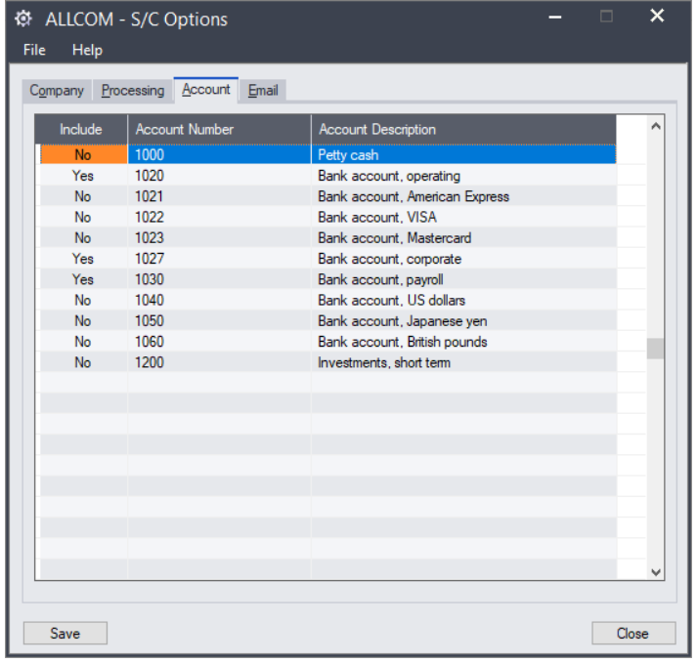

General Ledger Account balances will be extracted to reflect your cash and cash equivalent balances. This screen shows available accounts in your General Ledger and allows you to select or deselect them in the computation.

|  |  |
| --- | --- |
| **Fields** | **Purpose** |
| Include | Toggle to include or exclude this account from the cash and cash equivalent opening balance. |
| Account Number | This is the General Ledger Account Number for this inclusion/exclusion. |
| Account Description | This is the description of the General Ledger Account Number. |

* Email

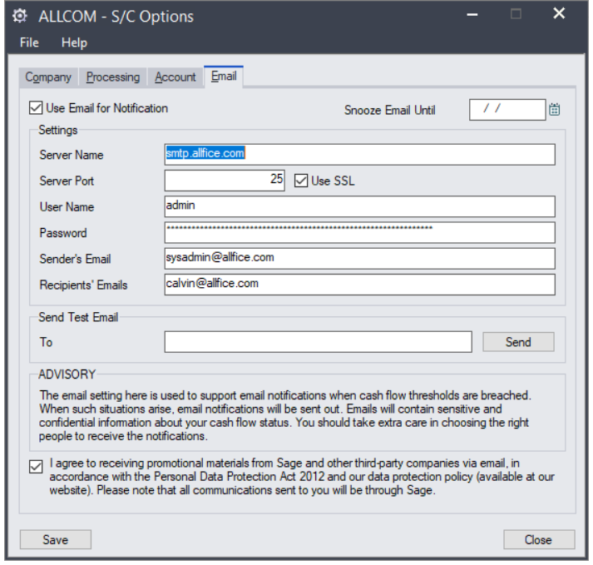

This is where you define the email settings needed to send you notification.

|  |  |
| --- | --- |
| **Fields** | **Purpose** |
| Use Email for Notification | Determine if you wish to use Email to notify recipients of any cash flow alerts. Turning this off means the only means of receiving notification is through the Inquiry function. |
| Snooze Email Until | If you wish to stop email notifications for a period of time, you can enter a date here. Settings here apply for all recipients. |
| Server Name | This is the name of your email server (you may need the assistance of your company’s IT department to set this up) |
| Server Port | The port used for sending of emails. |
| Use SSL | Indicate this if SSL is enabled on your email server. |
| User Name | Specify an email user name here as the program requires a legitimate email id for sending of emails. |
| Password | This is the password for the User Name used to send emails by this program. |
| Sender’s Email | Specify the email id that will be reflected as the sender of email notification. |
| Recipient’s Email | Indicate recipients that will be receiving email notification. You can separate the email addresses with a “;” subject a maximum of 255 characters for the full list. |
| Send Test Email To | Enter an email to receive a test email during testing of the settings here. |
| I Agree (checkbox) | With the collaboration with Standard Chartered in Singapore and Malaysia, the program may send loan offers to you. To ensure we have your consent to do this, this checkbox need to be checked to benefit for this. |

## Additional Notes on Settings/Options

If your country of incorporation of your business is in Singapore or Malaysia then you may benefit from Sage’s collaboration with Standard Chartered Bank. Other countries may be included in future.

You do not need to enable this as it is automatically enabled when you choose either Singapore or Malaysia for the Country value. And, when you choose Singapore or Malaysia, then it is important that you choose the right Entity Type and Industry to describe your business. If you select country as Singapore, then entering the new ACRA UEN in the “Business Reg. No” field will see the “Business Reg. Year” field being populated. For all others, please enter the year your business begins.

If your business is a foreign company and you need to set your Functional Currency to your Corporate Reporting currency whilst your Country selection is Singapore or Malaysia, then you will need to setup exchange rates to translate your balances to the country’s currency. Balances shown in the Inquiry screens and reports will still be in your Functional Currency but the program uses the rate to determine your eligibility for any loan offers.

Chapter 3: Security Configuration

## Create Security Groups

You create Security Groups, as follows:

* In the Administrative Services menu, double-click the Security Groups.
* Select Cash Flow Management 6.3A from the Application List.
* Enter a unique Group ID and a Description. The Group ID can be up to eight characters (letters from A to Z and digits from 0 to 9).
* Select the tasks that the Group can perform by checking it. You can unselect by unchecking it.
* Click Add.
* Repeat this for each group that you wish to create.

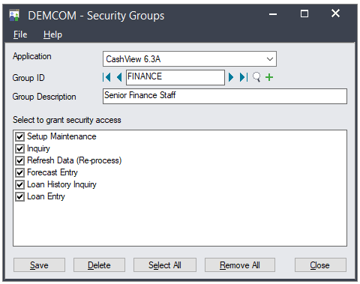

**Privileges provided by each task:**

|  |  |
| --- | --- |
| **Task** | **What does it control** |
| Setup Maintenance | With this you can maintain the settings in the Options screen. |
| Inquiry | Gives you access to the Inquiry function. |
| Refresh Data (Re-process) | Allow you view and run the Refresh feature in the Inquiry function’s Dashboard screen. This performs re-calculation of cash flow.  *\*This is only available for Sage 300 and it Includes Inquiry rights* |
| Forecast Entry | Allow you to enter Inflow and Outflow entries to your Cash Flow Summary screen.  *\*Includes Inquiry rights* |
| Loan History Inquiry | Allow you to view current and past bank loan records. This is only available to companies that are in Singapore and Malaysia (defined by the Country setting in Options).  *\*Includes Inquiry rights* |
| Loan Entry | Allow user the rights to perform loan submission.  *\*Includes Inquiry rights* |

## Authorizing User

You assign each user to one security group for each application. All users in the same group can perform the tasks defined for the group. The same user can be assigned to different groups within the same company.

**To assign user authorizations**

1. In the Administrative Services menu, double-click on the User Authorization icon.

The User Authorization dialog box appears:

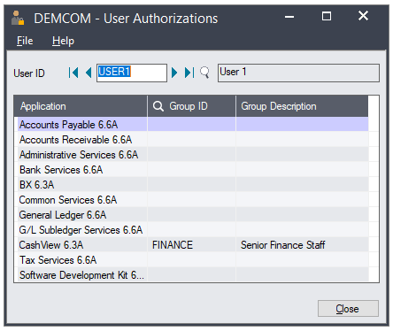

1. Select the User ID.
2. Locate Cash Flow Management 6.3A in the Application List.
3. Use the Finder to select a previously created Security Group.
4. Repeat these steps for each user that you want to allow access.

Chapter 4: Using the CashViewTM Inquiry Function

You can find the function in the CashViewTM menu. The function is called Inquiry.

The first screen you see when you start this function will depend on a number of conditions.

Here are the options:

|  |  |  |  |
| --- | --- | --- | --- |
| **Country** | **Exceed Cash Flow Threshold** | **Met Condition For Campaign Offer** | **What you will see** |
| Others | Y | NA | Alert message displayed |
| Others | N | NA | Dashboard |
| Singapore | Y | N | Alert message displayed |
| Singapore | Y | Y | Alert message and campaign offer displayed |
| Singapore | N | N | Dashboard |
| Singapore | N | Y | Campaign offer displayed |
| Malaysia | Y | N | Alert message displayed |
| Malaysia | Y | Y | Alert message and campaign offer displayed |
| Malaysia | N | N | Dashboard |
| Malaysia | N | Y | Campaign offer displayed |

These are the screen combinations shown:

* Only Alert displayed

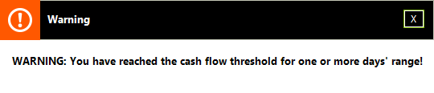

* Only Campaign offer displayed



* Both Alert and Campaign displayed

It will show the Alert box and when user closes that then it will show the Campaign box.

* No Alert and Campaign offer displayed

The dashboard will be shown.

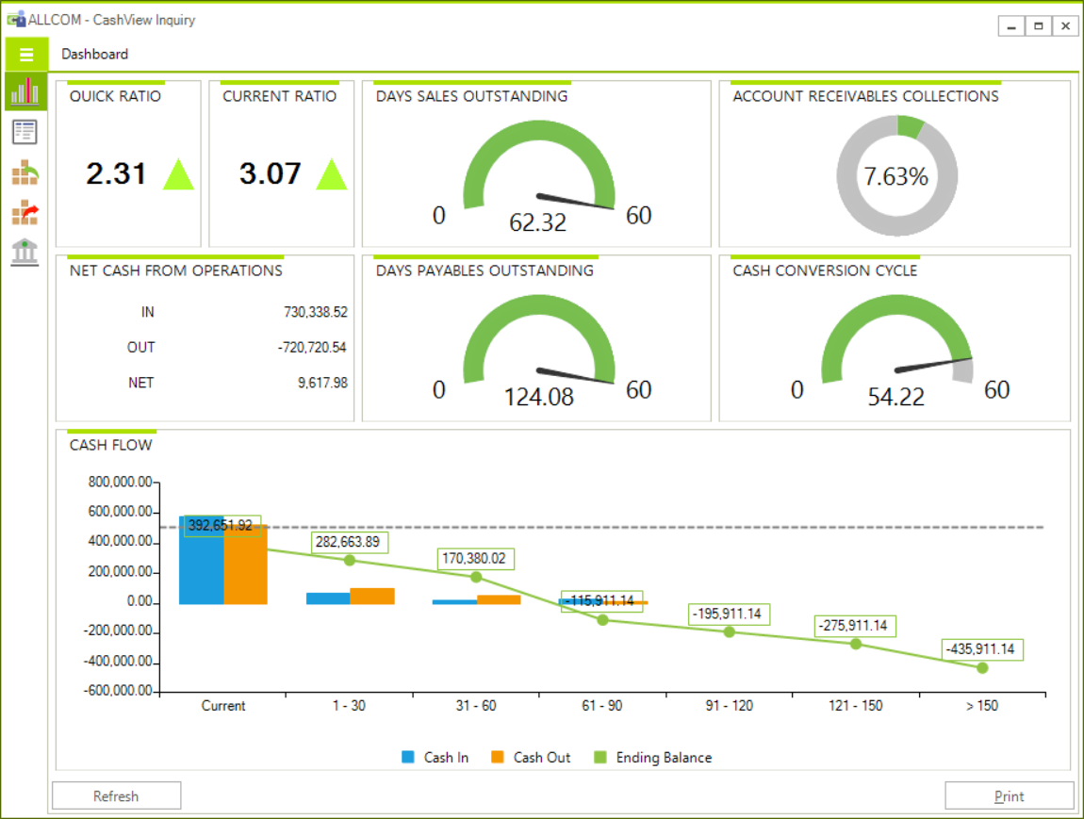

## Functions available

Subject to your security rights assigned to you, the following are the actions that can be performed in the Inquiry function (applicable to Sage 300 Interface).

| **Menu** | **Usage** |
| --- | --- |
| Dashboard | This is the main screen where you can see the current cash flow status of your business.  This screen also have the option to print the following report:   * Dashboard report |
| Cash Flow Summary | This screen shows the cash position over the days’ ranges that you have set up in your configuration. See *Cash Flow Summary* for more information. This screen also allows the input of financial and investment activities that are not included in your accounting data.  This screen also have the option to print the following reports:   * Summary Cash Flow Report * Cash and Bank Accounts * Inflow and Outflow Entries |
| A/R Summary – Top 10 Outstanding Balance | See the top 10 customers with the highest outstanding balance here.   * This screen also have the option to print the following reports: * Top 10 Customers Outstanding * Receivables Forecast |
| A/P Summary – Top 10 Outstanding Balance | See the top 10 vendors with the highest outstanding balance here.   * This screen also have the option to print the following reports: * Top 10 Vendors Outstanding * Payables Forecast |
| Loans | This is the function that you will use to submit a campaign offer request to participating third-party companies. |

*Note: To expand the menu (as shown below) you need to click on the button that has 3 horizontal bars*

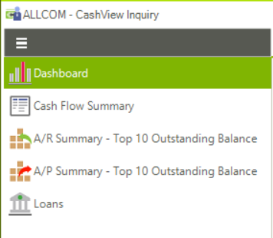

### Dashboard

This screen presents financial metrics in the form of charts and widgets. These are the available metrics and the detailed information about them.

**Quick Ratio**

The program uses an arrow (directional and coloured) besides a numeric value to indicate the result. The yardstick used to determine the direction and colour is a value of 1.1. This can be changed in the SC.INI file in the installation folder (See your Sage Business Partner for assistance if you cannot find this).

A value greater than 1 is a good indication that your cash flow position is able to meet its financial obligations from its current cash position. However, if the value goes below 1 then it indicates that your business is relying too much on moving its inventory or assets in order to meet your short-term liabilities.

The formula used for computing this is (Total Current Assets – Inventory) / Total Liabilities.

**Current Ratio**

Just like Quick Ratio, the program uses an arrow (directional and coloured) besides a numeric value to indicate your current ratio value. It is set to use a value of 1.0 for flagging the results. This can be changed in the SC.INI file.

Current Ratio is computed with Inventory included in the formula so that it represents a better picture of your cash flow since Inventory is least liquid of your assets. A value of 1 indicates that all your movable assets are just enough to pay off all your short-term liabilities.

The formula used is (Total Current Assets / Total Liabilities).

**Days Sales Outstanding (DSO)**

This is a metrics that indicates the average days your customers pay you. Use this information to compare with the typical terms you offer your customers. It should come close else it means your customers are not settling their AR in a timely manner.

The formula to compute this is

(((Begin Year AR + YTD AR) / 2) / Net Credit Sales) * Days since Start of Year

**Days Payables Outstanding (DPO)**

Just like DSO that measures the average days customers pay you, DPO measures the average days you take to pay your suppliers.

The formula for this is

(((Begin Year AP + YTD AP) / 2) / Cost of Goods Sold) * Days since Start of Year

**Account Receivables Collections**

This is also known as collections effectiveness index (CEI) and is an indicator of the percentage of your accounts receivable that was collected over a period of time. The value you see here measures this from the start of the fiscal year. Generally, it gets more informative as the fiscal year progresses.

The number to look out for is a value as close to 100%. This means your collection is very effective. Too low a value should be a concern and has to be investigated. Similarly, if the value is too far above 100% then it should also be a concern.

Used in conjunction with the other metrics, you should be able to strike a fine balance between collection effectiveness and effective credit management.

**Cash Conversion Cycle (CCC)**

Typically, this metric is best served when you are able to compare against a longer period of time, like over a period of years. A lower value means better performance from your business. However, it is also dependent on the nature of your business.

With a lower value, it means you are you are able to move inventory faster with sales and you are able to meet your payment obligations more promptly and also you are collecting accounts receivable on time.

The formula for this is

CCC = DIO + DSO – DPO

*Note: DIO (Days Inventory Outstanding) is a measurement of time taken to convert inventory into revenue. The formula for this*

(((Begin Year Inventory + YTD Inventory) / 2) / Cost of Goods Sold) * Days since Start of Year

**Net Cash from Operations**

This widget provides a quick look at your inflow and outflow purely from the Sales and Purchase activities. This is purely from the operating activities perspective.

It is useful assessment of how regular business activities, i.e. Sales can be used to offset purchases without the inclusion of other activities such as working capital.

**Cash Flow**

This is depicted using a combination of line and bar chart. The line chart is the threshold value you have configure in the application while the vertical bar chart is the depiction of your cash inflow and outflow.

### Cash Flow Summary

The cash flow summary screen uses a layout that shows how your cash flow status looks like over time (days’ ranges). Beginning from top row, it shows your cash position (based on amounts in your cash and bank accounts configured for this) over each days’ range after accounting for any movements during the period.

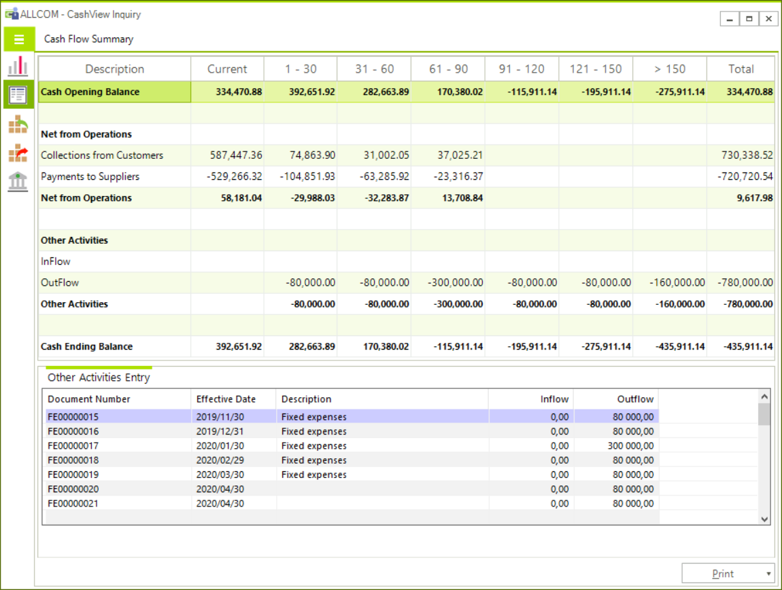

Opening balance from Cash and Bank accounts defined in Settings->Options. Days’ ranges can be set there too.

Any activities that can affect cash flow but not posted in your system can be entered here

Movement are recorded for each days’ range and closing balance for each are shown

The Print button provides for 3 reports. You can learn more about them in *Appendix A: Understanding Cash Flow reports.*

### A/R Summary - Top 10 Outstanding Balance

This screen shows ten customers with the highest outstanding balance. It has information on the credit amount you have extended to them (in customer currency) and also the highest balance they reached in the year. This information is shown in a tabular form as well as in a horizontal bar chart.

It also has 2 types of reports that you can print.

* **Top 10 Customers by Outstanding Balance**
* **Receivables Forecast**

*Note: See Appendix A: Understanding Cash Flow reports for more information.*

### A/P Summary – Top 10 Outstanding Balance

This screen shows ten vendors with the highest outstanding balance. It has information on the credit amount extended to your company by them (in the currency that you transact with them) and also the highest balance that you have reached in the year. This information is shown in a tabular form as well as in a horizontal bar chart.

It also has 2 types of reports that you can print.

* **Top 10 Vendors by Outstanding Balance**
* **Payables Forecast**

*Note: See Appendix A: Understanding Cash Flow reports for more information.*

**Loans**

This screen is only visible to you if you have configured your Country of business is in Singapore or Malaysia. If you have chosen “Others” then this menu is invisible to you. See *Settings->Options* for information.

Additionally, you can only see this if your security rights allow you to.

This screen is used when you wish to take advantage of Campaign Offers that are offered to you from time to time. You can get to this screen either by clicking on the Campaign Offer banner screen or when you click on the menu item.

Loan offers are non-binding offers. Submission will still require the typical due diligence by the company that is making the offer. However, as the offer is made through this function, it enjoys some special arrangements. See *Terms and Conditions* in the function.

The Campaign Offers are reflected as Loans in the function. Each record has a status field that reflects its current status. Here is the list and what it means:

|  |  |
| --- | --- |
| **Status** | **Meaning** |
| New | This is a new offer and you have not taken any action on it. |
| Submitted | You have submitted a request for the offer. |
| Cancelled | You have cancelled the offer. |
| Approved | You have marked the offer as being approved. |
| Rejected | You have indicated the submission was rejected. |

*Note: The Status does not automatically change by itself other than the change from New to Submitted. You are required to use this screen to maintain the status of the offer.*

Here is what you need to do before you can “Submit” the request for the offer.

| **Field Name** | **Editable** | **Purpose** |
| --- | --- | --- |
| Loan Request Details |  |  |
| Reference | No | This is a fixed internal reference. |
| BRN | No | This is automatically taken from Settings->Options. |
| Loan Cap Amount | No | This is fixed to the Campaign Offer. |
| Loan Requested | Yes | You can enter a value equal or less than the Loan Cap Amount. |
| Status | No | This indicates the status of the record. |
| Date Submitted | No | This is the date updated by the program when you submit. |
| Contact Information |  |  |
| Key Contact | Yes | This is taken from Settings->Options. |
| Legal Name | Yes | This is taken from Settings->Options. |
| Address | Yes | This is taken from Settings->Options. |
| City | Yes | This is taken from Settings->Options. If your country of business is Malaysia then you should indicate the City or Town name. |
| State | Yes | This is taken from Settings->Options. If your country of business is Malaysia then you should indicate the State name. |
| Country | Yes | This is taken from Settings->Options. |
| Postal Code | Yes | This is taken from Settings->Options. |
| Phone | Yes | This is taken from Settings->Options. |
| Mobile | Yes | This is taken from Settings->Options. |
| Email | Yes | This is taken from Settings->Options. This is the email that will automatically receive a copy of the submission. |
| Email Submission Details |  |  |
| From | No | This is the email ID for your user account that is defined in Administrative Services->Users. |
| To | No | This is the email ID of the company involved in the Campaign Offer. |
| CC | Yes | If you wish to have a copy of this submission email sent to persons other than the person in the Email field then you will enter them here with a semicolon “;” to separate them. |
| Subject | No | This is fixed and reflects the Campaign Offer. |
| Additional Comments | Yes | You may add (up to 255 characters) comments that will be included into the submission email. |

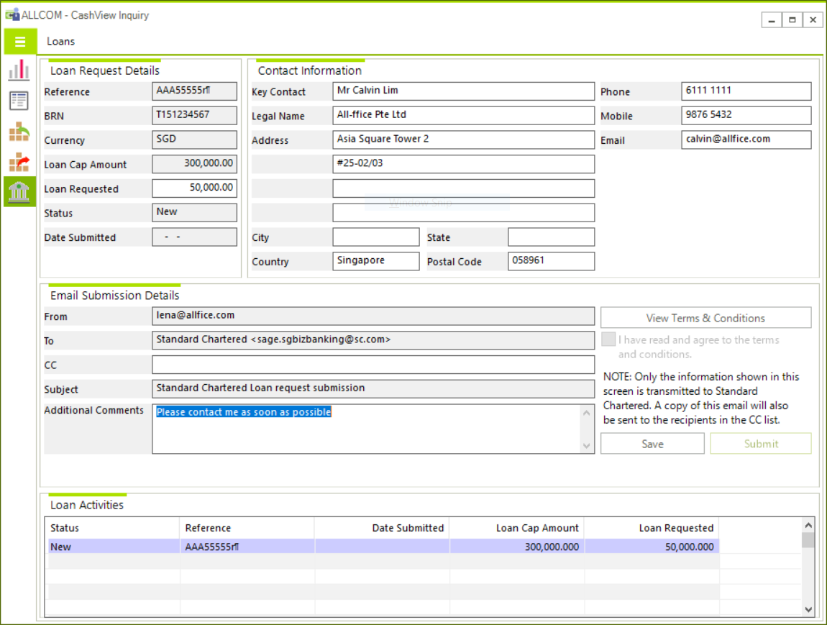

**Typical Submission Email**

Subject: Standard Chartered Loan request submission

Dear Standard Chartered,

This is a loan request submission sent from Sage 300 application.  
Please kindly contact the person below to discuss financing options.

|  |  |
| --- | --- |
| Date | 08/10/2019 |
| Reference No. | AAA5555589 |
| Loan Cap Amount | SGD 300,000.00 |
| Loan Request Amount | SGD 50,000.00 |
| Main Contact | Mr Calvin Lim |
| Company Legal Name | All-fice Pte Ltd |
| Address | Asia Square Tower 2 #25-02/03 |
| City/Town |  |
| State |  |
| Country | Singapore |
| Postal Code | 058961 |
| Office No. | 61111111 |
| Mobile No. | 98765432 |
| Email | calvin@allfice.com |
| Additional Comments | Please contact me as soon as possible |
| Terms and Conditions | Agreed |

**Terms and Conditions**

1. Your company's eligibility for a Standard Chartered Bank (Singapore) Limited ("Bank") Business Instalment Loan ("Loan") of up to the amount specified above is determined by SAGE based solely on your company's financial and transactional information available to Sage on the [Sage 300 platform], as measured against a few basic financial criteria provided by the Bank for determining eligibility for the Bank's Loan product (which is subject to change from time to time). Receipt of this eligibility message should therefore not be construed as a guarantee of Loan approval for up to the amount specified.
2. Loan approval and quantum remain entirely subject to the company's formal application and complete supporting documents being received by the Bank and the Bank's full underwriting process. Required supporting documents will include (but is not limited to):
   1. Photocopies of Sole Proprietors' / Partners' / Principals' / Directors' Identity Cards / Passports
   2. Company's Goods and Services Tax statements for last 4 Quarters
   3. Company's operating bank current account statements for the past 6 months
   4. Completed Business Instalment Loan Application form
   5. Copy of Sole Proprietors' / Partners' Income Tax Notice of Assessment
   6. Board of Directors' resolution
   7. Company Constitutional Documents like Memorandum and Articles of Association
   8. Professional Certificate (if applicable)
   9. Documents related to establishment of entity, identity and address proof documents
3. Documents related to establishment of entity, identity and address proof documents
   1. Confirm your company's interest in applying for the Loan and your authority to submit this expression of interest on your company's behalf;
   2. Consent to the Bank contacting the representative named in this form to follow up on the company's application, including the submission of complete supporting documents;
   3. Authorise, on behalf of the company, the disclosure of the company's financial and transactional information available to Sage on the [Sage platform] by Sage to the Bank;
   4. Confirm, for and on behalf of the company that, you have read, understood and agree that all information provided by the company will be handled in accordance with the Bank's Privacy Statement for Singapore Corporate and Institutional Clients available on the Bank's website at https://www.sc.com/sg/privacy/; and
   5. Acknowledge that the Bank may decline your company's application for the Loan without giving any reason or notice.

**Actions You Can Take**

This form is used to submit a request in response to a campaign offer. It is also used to update the record with the changing status.

The following are the actions possible with each record Status.

|  |  |
| --- | --- |
| **Status** | **Actions** |
| New | Any new Campaign Offer is set as New. You cannot change it to any status other than to Submitted via the Submit button. If you are not ready to submit but has made changes to the entry you can use the Save button to save changes made. |
| Submitted | You cannot set the status to Submitted other than by clicking on the Submit button. Once changed to Submit, it is possible to Re-Submit. You can also change its status to one of Cancelled, Approved or Rejected. |
| Cancelled | You can set a record to Cancelled if it is in Submitted state. Once it is changed to Cancelled, the record cannot be edited or its status changed. |
| Approved | You can set a record to Approved if it is in Submitted state. Once it is changed to Approved, the record cannot be edited or its status changed. |
| Rejected | You can set a record to Rejected if it is in Submitted state. Once it is changed to Rejected, the record cannot be edited or its status changed. |
| View Terms & Conditions | You need to click on this button to view the terms and conditions and then later to check the I Agree checkbox before you can Submit. |
| I Agree checkbox | This is enabled only when you have viewed the T&C using the View Terms & Conditions button. The selection for this is not saved when you exit this function. This is intentional as it is possible another user in your company may use this function to submit at a different time. |

**Loan Activities**

This shows the various Loan records in your system. There can only be one record of status New or Submitted. However, there can be many records of the other status types. You cannot edit the grid directly but by selecting a row, the details will be shown in the form above.

|  |  |
| --- | --- |
| **Field Name** | **Purpose** |
| Status | This is the status of the record. It can be New, Submitted, Cancelled, Approved or Rejected |
| Reference | This is a fixed internal reference number. |
| Date Submitted | This is automatically assigned when it is submitted. |
| Loan Cap Amount | This is fixed for the Campaign. |
| Loan Requested | You can only enter a value smaller or equal to the Loan Cap Amount. |

*Note: See Appendix: Understanding Cash Flow Reports for detailed information on the reports that you can print*

Appendix A: Understanding CashViewTM reports

**Cash Management Option Settings (SCOPT.RPT)**

This report prints the settings currently in place for the module. Use this report to record down your configuration settings.

**For description of account groups please see table at the end of this Appendix.**

*Note: This report is also generated when you run a test send of email.*

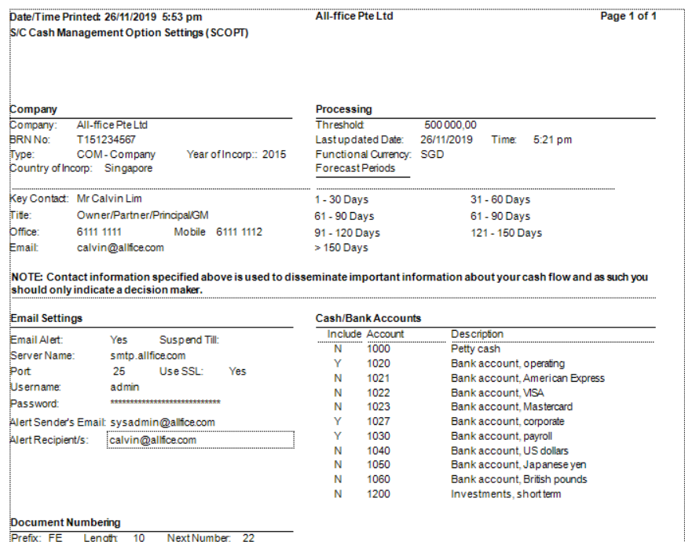

**Cash Flow Management Dashboard Report (SCSUM01.RPT)**

This report represents what you see in the Dashboard (a close equivalent). It contains a number of pages that shows the following:

* **Current and Quick Ratio**

The formula used to compute this is based on the current Fiscal Year and Period. It takes Total Current Assets less Inventory and divides the result with Total Current Liabilities for Quick Ratio and includes Inventory for the Current Ratio.

* Total Current Assets is represented as account balances belonging to Account Groups 10, 20, 30 and 40.
* Inventory is represented as account balances belonging to Account Group 30.
* Total Liabilities is represented as account balances belonging to Account Groups 80, 90 and 100.

*Note: To determine whether the ratio is good or bad, it is being compared to 1.1 for Current Ratio and 1.0 for Quick Ratio. You can change this for the on screen display by editing the SC.INI file found in the module’s installation folder. However, the change will not be reflected here unless the report is edited. Please get assistance from your Sage Business Partner if you would like to change it.*

* **A/R Collections metric**

This is a simple metric to measure the efficiency of A/R collections. The formula used is to divide the YTD collections by the YTD A/R.

* **Days Sales Outstanding (DSO)**

The formula to compute the number of days it will take to collect after a sales is made is based on the beginning year’s A/R balance and averaging it with the current YTD A/R balance. This is then divided with the YTD Credit Sales (Revenue) and then finally multiplied by the number of days since the start of the fiscal year.

* A/R balances are taken from accounts in the Account Group 20.
* Revenue balances are taken from accounts in the Account Group 140.

*Note: Fiscal Year, Period and Fiscal Year Start Date information are passed to the report by the Dashboard program.*

* **Days Payables Outstanding (DPO)**

The formula to compute the number of days a company typically takes to pay off its bills is based on the beginning year’s A/P balance and averaging it with the current YTD A/P balance. This is then divided with the YTD Cost of Goods (COGS) and then finally multiplied by the number of days since the start of the fiscal year.

* A/P balances are taken from accounts in the Account Group 80.
* COGS balances are taken from accounts in the Account Group 150.

*Note: Fiscal Year, Period and Fiscal Year Start Date information are passed to the report by the Dashboard program.*

* **Days Inventory Outstanding (DIO)**

This metric is documented here but is not shown as a metric. Instead it is used in the computation of Cash Conversion Cycle. The formula to compute the number of days it will take to sell off inventory is based on the beginning year’s I/C balance and averaging it with the current YTD I/C balance. Then, it is divided with the YTD Cost of Goods (COGS) and finally multiplied by the number of days since the start of the fiscal year.

* I/C balances are taken from accounts in the Account Group 30.
* COGS balances are taken from accounts in the Account Group 150.

*Note: Fiscal Year, Period and Fiscal Year Start Date information are passed to the report by the Dashboard program.*

* **Cash Conversion Cycle (CCC)**

This metric measure in days the time it takes to convert Inventory into Sales. The formula is based on the calculations for DIO, DSO and DPO. It is DSO + DIO – DPO.

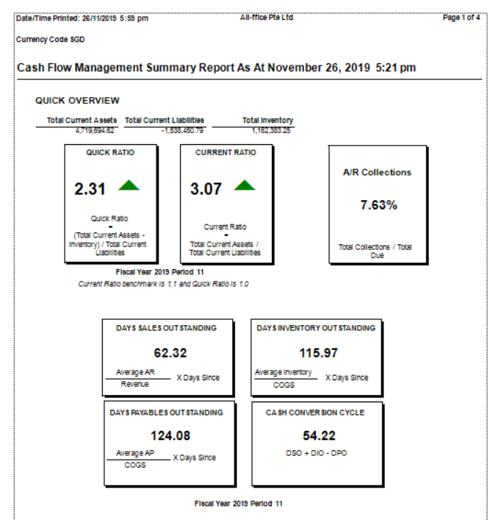

The second page of the report shows Net Cash from Operations. It has a number of useful values in the report.

* It has a side by side comparison of the data as shown in the Summary screen for the Days’ Ranges. This is useful if the layout you need is different from the Inquiry screen.
* Vertical bar charts are used to show distribution of A/R, A/P and Other Activities. This depiction is different to the Inquiry screen because of the limitation of Crystal Reports.

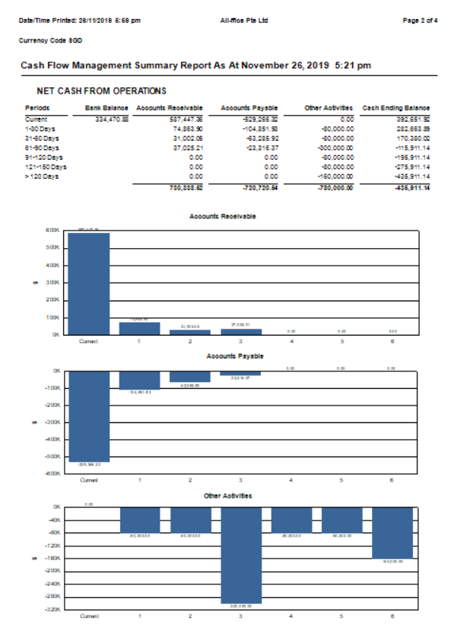

The next two pages of the report shows the same information as the Inquiry function’s A/R Summary and A/P Summary screens.

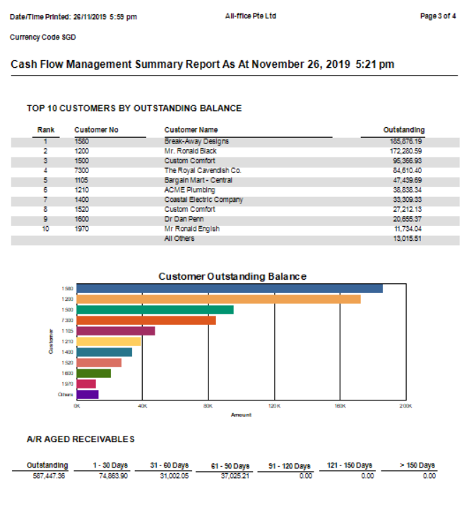

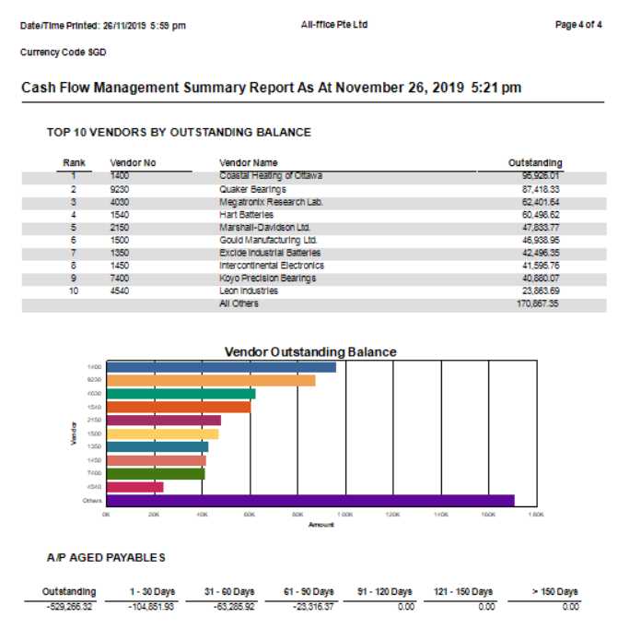

**Summary Cash Flow Report (SCSUM03.RPT)**

This report shows the same information found in the Summary screen of the Inquiry function. Take note of the following:

* Cash and Bank balances are computed as at the fiscal year and period indicated. See *Cash and Banks* report for information.
* The collections and payments amounts are based on the same computation as the A/R Receivables Forecast and A/P Payables Forecast reports.
* The threshold amount used is set in Settings/Options function.
* Closing Balance is shown in red should any of the Days’ Range exceeds the threshold amount.

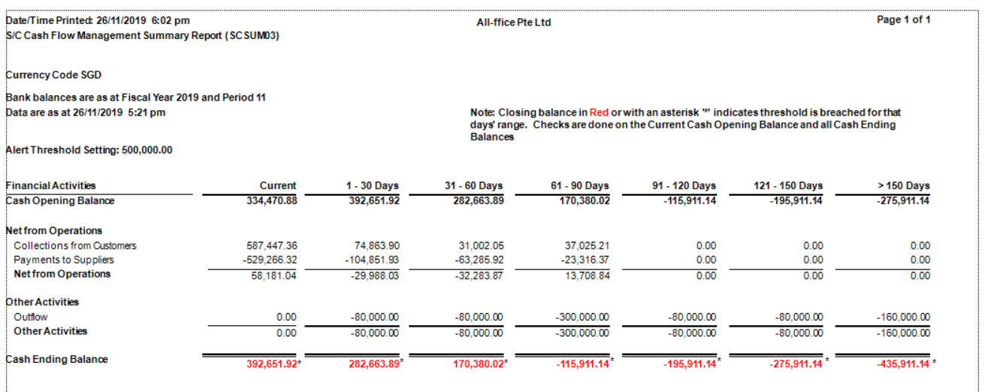

**Cash and Banks (SCCABK.RPT)**

This report shows the Cash and Bank accounts used for the determination of cash balances in the module.

The list of General Ledger accounts shown are built from accounts belonging to Account Group 10. Whether they are included or excluded from the calculation will depend on the setup in Options. You can change them as necessary, however the balance will only be refreshed during the next daily refresh (occur with the first log in for the day) or when user clicks on Refresh in the Dashboard screen.

Although the report shows Fiscal Year and Period parameters, you cannot specify them when you print. They are automatically determined using the fiscal calendar based on today’s date.

*Note: For description of account groups please see table.*

*Note: There are 2 types of Account Groups in the system. Those that are coded in multiple of tens are the in-built groups and CashViewTM uses those. The other Group is user defined and can be any code value chosen by the person defining it. These are not used in CashViewTM.*

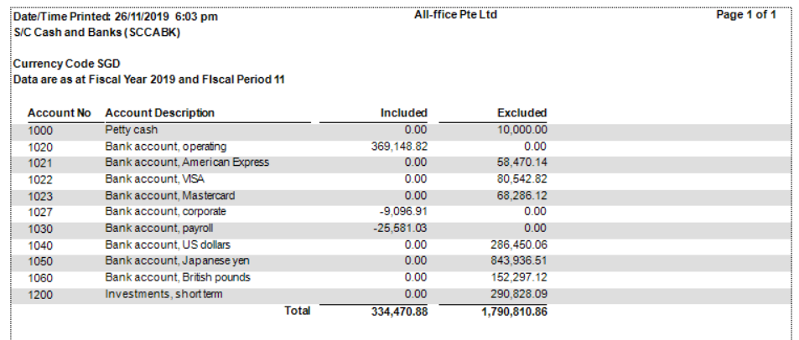

**Activities from Financing and Investment Activities (SCINOUT.RPT)**

This report shows the manual entries entered in the Inquiry Summary screen. These are typically entries that are either not entered yet in your accounting data or they are entries that are in planning stages. However, the amounts are important to obtain a reasonable cash flow position.

*Note: The Effective Date entered determines the Days’ Range and the column that the amount will be reported in.*

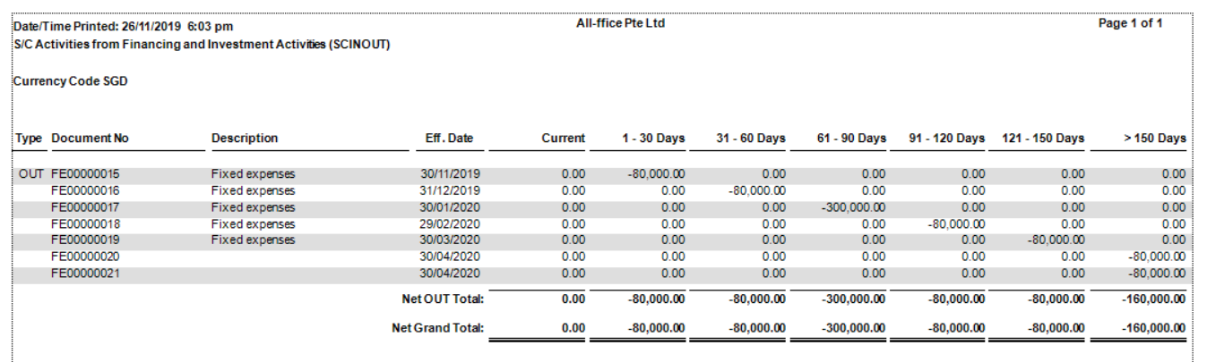

**A/R Top 10 Customers by Outstanding Balance (SCARTOP.RPT)**

This report shows the same information shown in the A/R Summary screen in the Inquiry function. It is useful if you need a copy of what you see in the screen.

The information here is as at the last date and time when the cash flow data was refreshed. The Highest Balance in Functional Currency is not calculated in this module. It is the values maintained by the core A/R module. You can see this amount in the Customer Master.

*Note: If there are significant changes that need to be reflected in the report, you can perform a Refresh in the Dashboard screen. However, security access right is needed to perform this.*

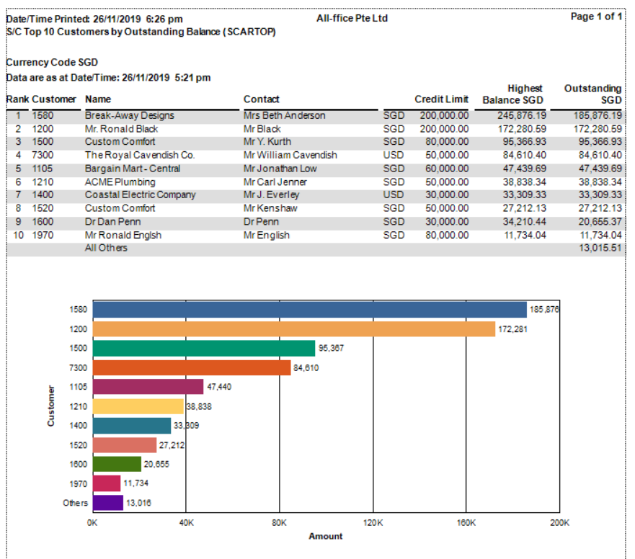

**A/R Receivables Forecast report (SCARAGED.RPT)**

This report provides a detailed look at A/R collections over the projected future days’ ranges. Unlike the standard A/R Aged Receivables report in the Accounts Receivable module, this report differs in the following areas:

* It provides for up to 7 ranges – Due plus 6 user defined ranges.
* It shows the percentage of balances for each range against the total outstanding for the Customer.
* It shows the percentage of balances for each range for all customers against the total outstanding for all Customers.
* Where multi-receipts are used, the report shows them separately with their calculated Due Date instead of treating them as due based on the first receipt due date. This is a better reflection of the receivables due.

*Note: To change the Days’ Ranges please refer to your Settings Options function.*

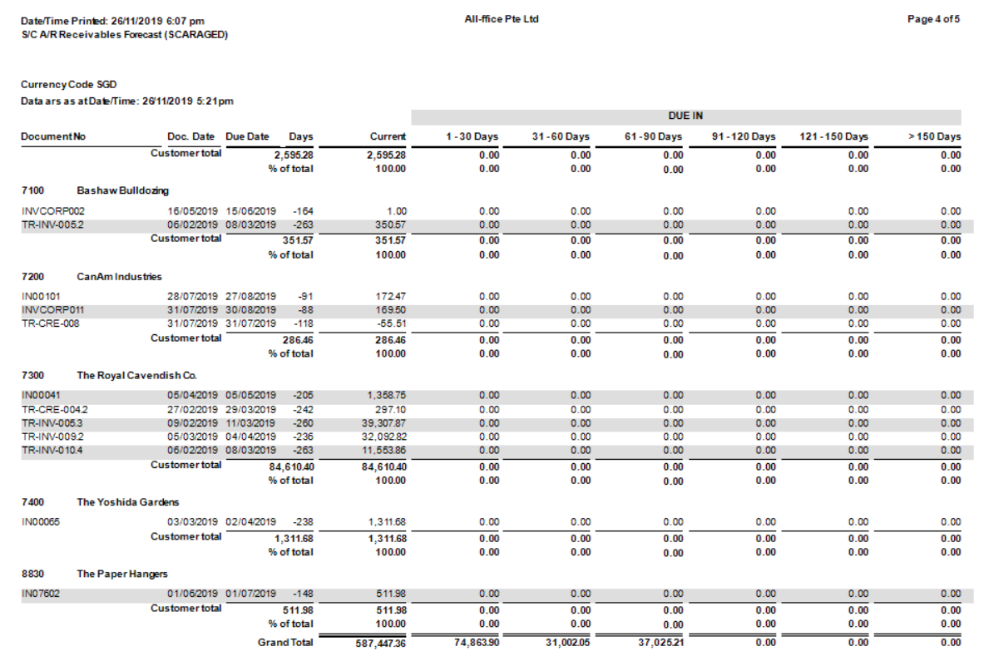

**A/P Top 10 Vendors by Outstanding Balance (SCAPTOP.RPT)**

This report shows the same information shown in the A/P Summary screen in the Inquiry function. It is useful if you need a copy of what you see in the screen.

The information here is as at the last date and time when the cash flow data was refreshed. The Highest Balance in Functional Currency is not calculated in this module. It is the values maintained by the core A/P module. You can see this amount in the Vendor Master.

*Note: If there are significant changes that need to be reflected in the report, you can perform a Refresh in the Dashboard screen. However, security access right is needed to perform this.*

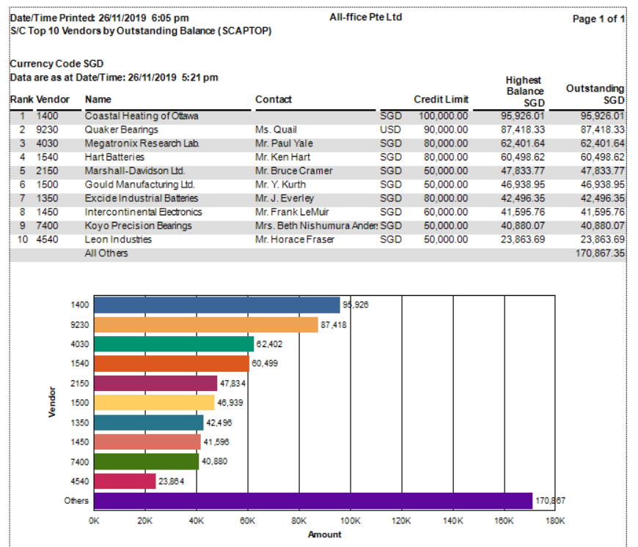

**A/P Payables Forecast report (SCAPCASH.RPT)**

This report provides a detailed look at the cash requirements over the projected future days’ ranges. Unlike the standard A/P Cash Requirements report in the Accounts Payable module, this report differs in the following areas:

* It provides for up to 7 ranges – Due plus 6 user defined ranges.
* It shows the percentage of balances for each range against the total outstanding for the Vendor.
* It shows the percentage of balances for each range for all vendors against the total outstanding for all Vendors.
* Where multi-payments are used, the report shows them separately with their calculated Due Date instead of treating them as due based on the first payment due date. This is a better reflection of the payables due.

*Note: To change the Days’ Ranges please refer to your Settings Options function.*

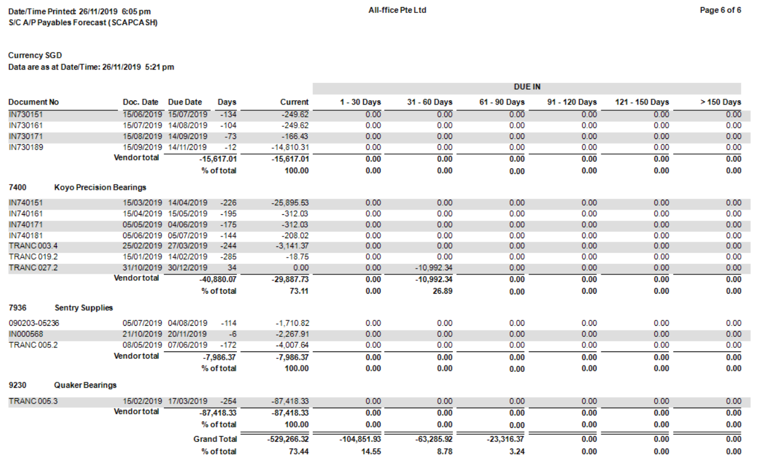

**Account Groups and Description**

|  |  |
| --- | --- |
| Group | Description |
| 10 | Cash and Cash Equivalent |
| 20 | Accounts Receivable |
| 30 | Inventory |
| 40 | Other Current Assets |
| 80 | Accounts Payable |
| 90 | Other Current Liabilities |
| 100 | Long Term Liabilities |
| 140 | Revenue |
| 150 | Cost of Sales |

Appendix B: Customization

There are a few settings that can be set in the system that can change the behaviour of the application. These are settings defined in the application’s INI file.

In the installation folder for CashViewTM, typically this is in:

<Drive Letter>:\Sage\Sage300\SC63A

There is a module ini file called SC.INI. Edit this file using Notepad and the following can be safely set.

|  |  |  |
| --- | --- | --- |
| **Parameter** | **Value** | **Effect** |
| [Dashboard] |  |  |
| QuickRatioBreak | 1.0 | Set the benchmark value to use. If result falls below it then the indicator will be a red down arrowhead |
| CurrentRatioBreak | 1.1 | Set the benchmark value to use. If result falls below it then the indicator will be a red down arrowhead |
| DSOMaximum | 60 | Set the max scale of the gauge used. If result is beyond that then it will show a red gauge |
| DSOMedian | 30 | Set the typical average value expected for this metric |
| DPOMaximum | 60 | Set the max scale of the gauge used. If result is beyond that then it will show a red gauge |
| DPOMedian | 30 | Set the typical average value expected for this metric |
| DIOMaxim | 60 | Not currently shown in dashboard |
| DIOMedian | 30 | Set the typical average value expected for this metric |
| CCCMaximum | 60 | Set the max scale of the gauge used. If result is beyond that then it will show a red gauge |
| CCMedian | 30 | Set the typical average value expected for this metric |
|  |  |  |
|  |  |  |
|  |  |  |
|  |  |  |